***Screenshot of E-Circuit of Linear Variable Differential Transformer (LVDT).***

*1. Experimental-Setup & Graph.*

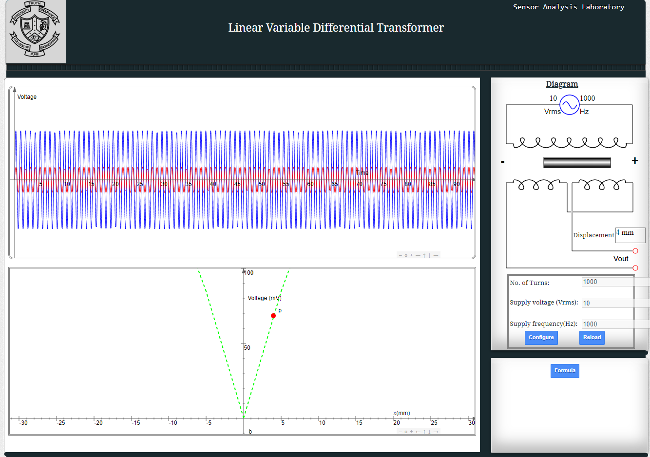

***Screenshots of E-Circuit of Strain Gauge.***

*1. Experimental-Setup.*

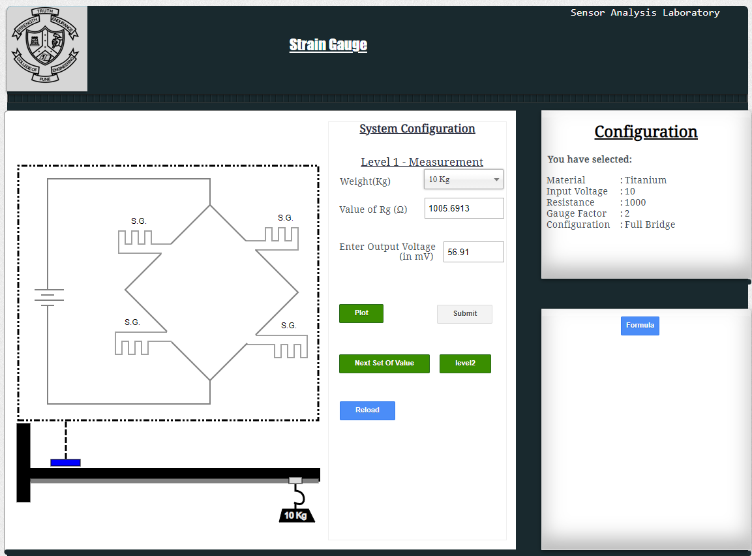

*2. Graph.*

